Algebra 1: Unit 9, Lesson 11

- Thomas is expanding an area for llamas in a petting zoo. The original area was $14$ feet (ft) by $22$ ft. After expanding the area by $x$ feet on all sides, the zoo would like the new area to be $1140$square feet. The original area and expanded area are shown.
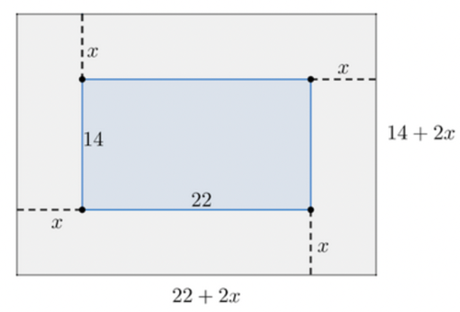
Write an equation that Thomas can use to determine how many meters the area should be expanded by in all directions.

$$\left(22+2x\right)\left(14+2x\right)=1140$$

- An object is propelled from a height of $18$ feet. The table shows the time, $t$, in seconds, and the height, $h$, in feet, of the object.
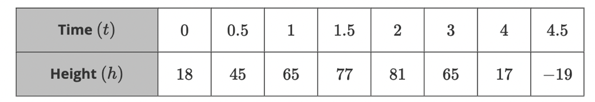
The function that models the height is $h(t)=-16{(t-2)}^{2}+81$ is shown on the coordinate grid.
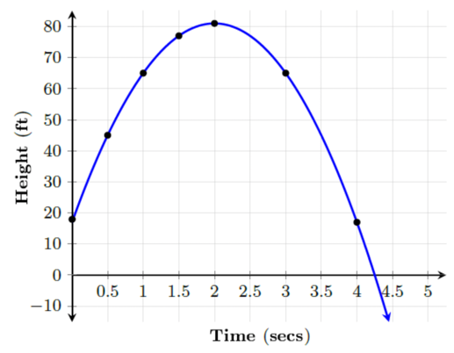
What is the approximate time, in seconds, when the object hits the ground?

$4.25$ seconds

- Tristan needs to find the height, $h$, in meters, of a rectangle which he knows has an area of $72$ square meters. The height of the rectangle is equal to twice its width in meters, $w$, minus seven.
Tristan wrote the equation for the height of the rectangle as $h=2w-7$. Then he used the formula for the area of a rectangle, $A=hw$ to write the equation
$72=\left(2w-7\right)w$. Tristan then found the height of the rectangle to be _______.
$$9$$

